Lab task 7

Task 1: Click Counter

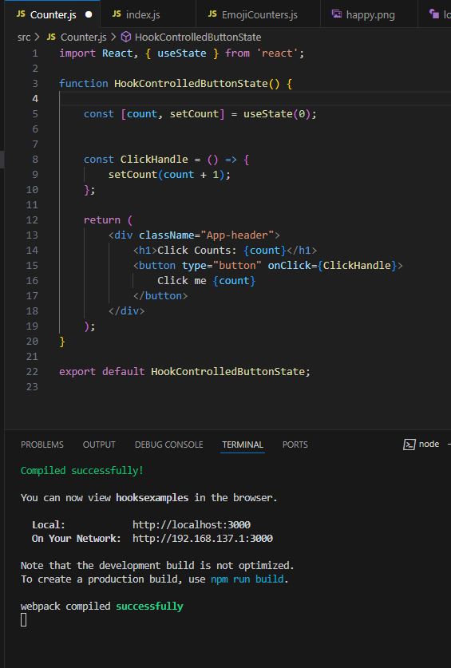

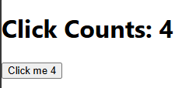

The click counter is a functional component that uses the useState hook to manage a count state. Each time the button is clicked, the count increments, and the UI updates dynamically. The ClickHandle function is assigned to the button's onClick event, which updates the state using setCount(count + 1). This demonstrates how React hooks simplify state management in functional components.

Task 2: Emoji Counter

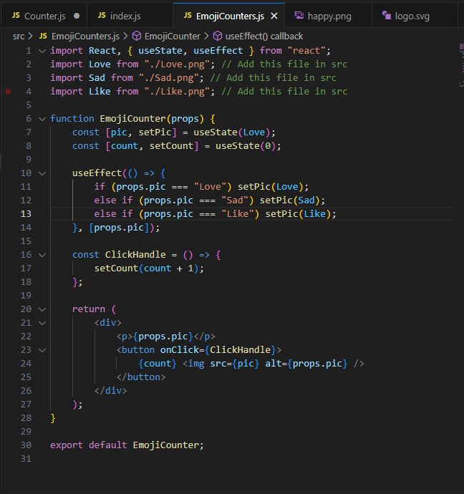

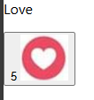

The emoji counter is another functional component named EmojiCounter. It uses two state variables (pic and count) managed by the useState hook. The useEffect hook ensures the correct emoji image is displayed based on the pic prop passed from the parent. Three instances of EmojiCounter are used for "Love," "Sad," and "Like," each rendering its respective emoji image and count. The click functionality increments the count for each button, showing how props and state interact.

Index code:

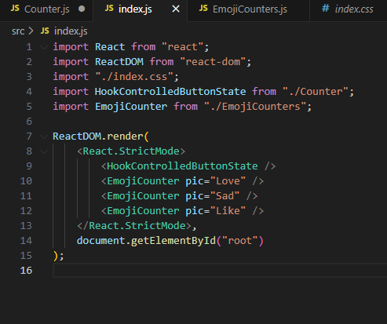

This file renders the HookControlledButtonState component (Task 1) and three instances of the EmojiCounter component (Task 2) for "Love," "Sad," and "Like." The pic prop determines which emoji image and description are displayed.

Full UI:

